**PROJECT REPORT**

***INDIA’S AGRICULTURAL CROP PRODUCTION ANALYSIS***

***(1997-2021)***

**TEAM ID:**

**NM2023TMID06079**

**Introduction**:

* 1. *Overview:*

India's Agriculture Crop Production report shows us the

multifaceted world of agriculture in India, providing a comprehensive

analysis of crop production trends, regional variations, challenges,

technological advancements, government policies, and future prospects. This report helps us in understanding the critical role of agriculture in India's economy and its impact on the livelihoods of millions of people.

*1.2 Purpose:*

1.Inform: Share essential data and insights about Indian agriculture with a wide audience, making it easy for people to understand the current scenario.

2.Educate: Help individuals, including students and policymakers, learn about the importance of agriculture in India and the challenges it faces.

3.Guide Decision Making: Assist business, investors, and policymakers in making informed decisions related to agriculture, such as investments and policy changes.

4. Create Awareness: Increase awareness among the public and

international community about the significance of sustainable agriculture for India's future.

5.Research: Serve as a foundation for further research and

academic studies on Indian agriculture.

**2.Problem Definition & Design Thinking:**

*2.1 Empathy Map:*

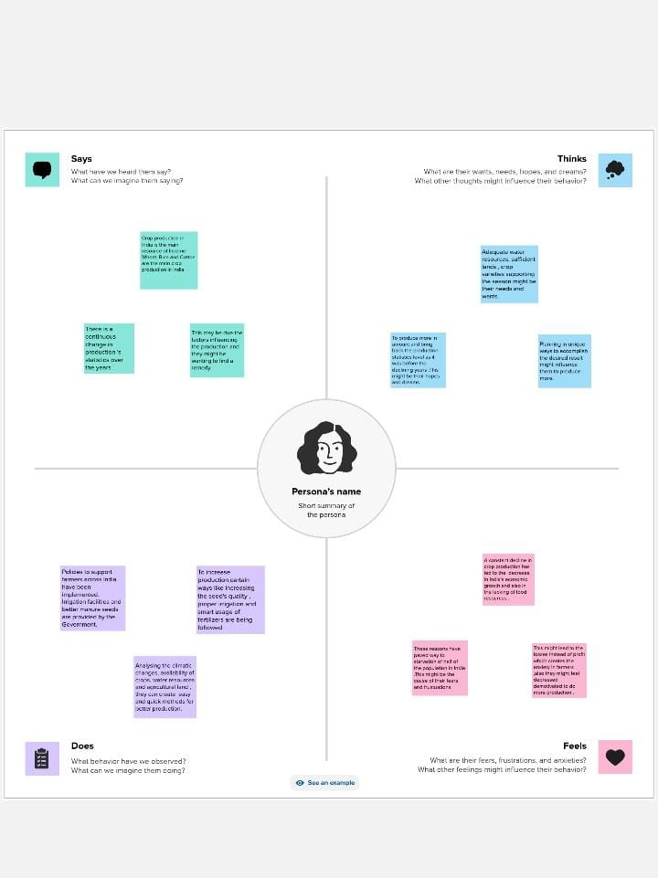



*2.2 Ideation and Brainstorming map :*

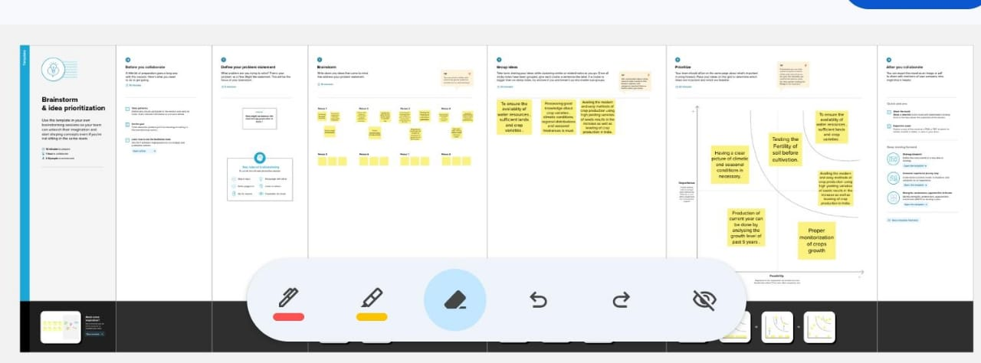

**3.RESULT:**

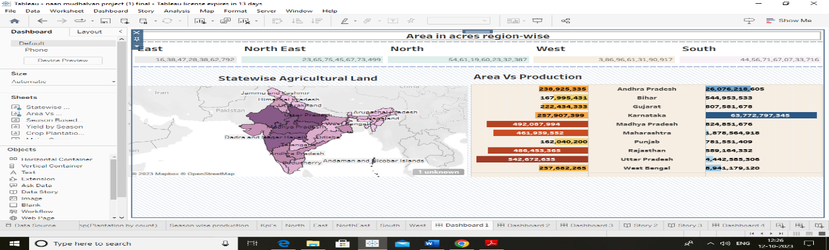

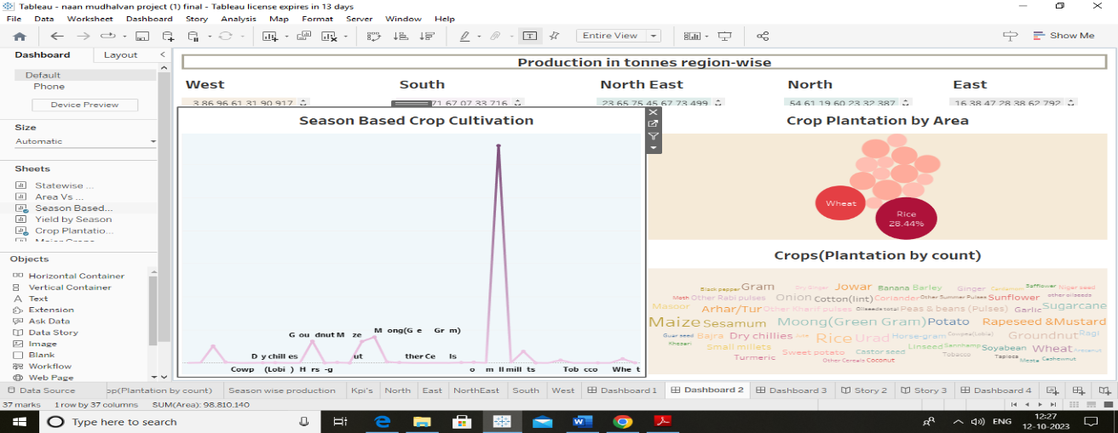

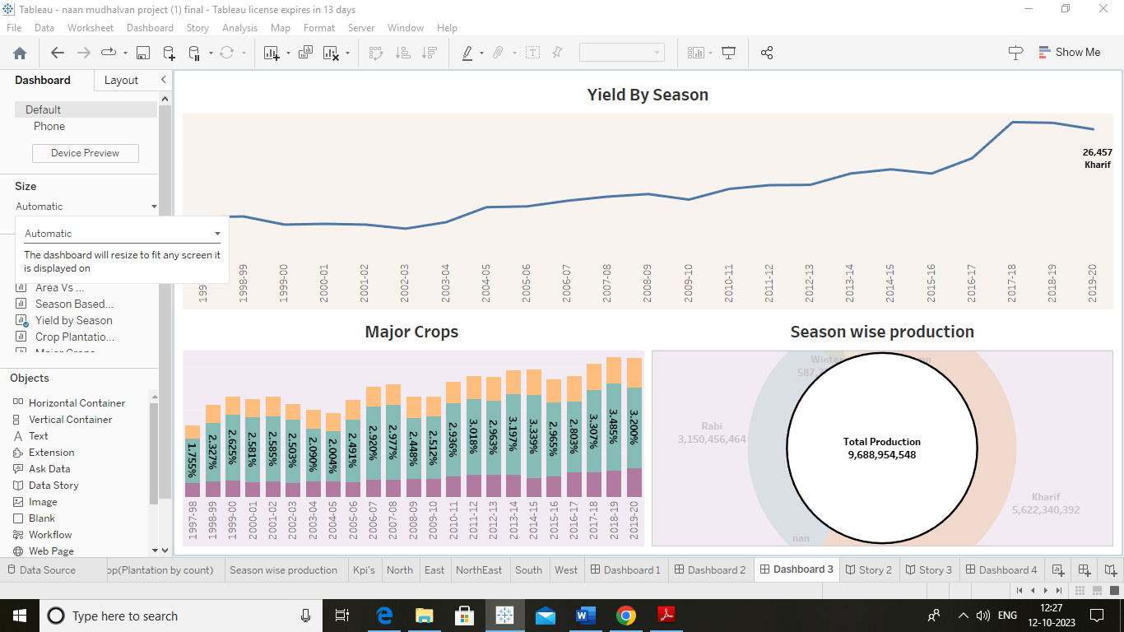

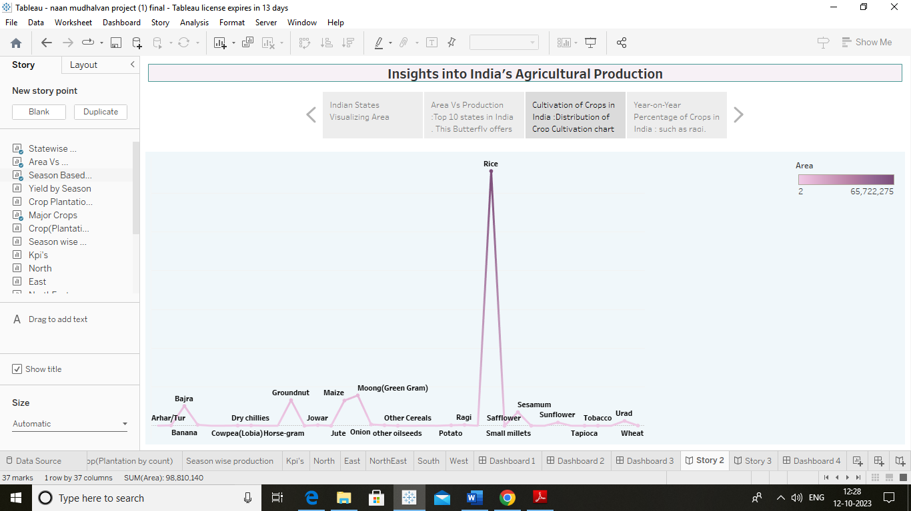

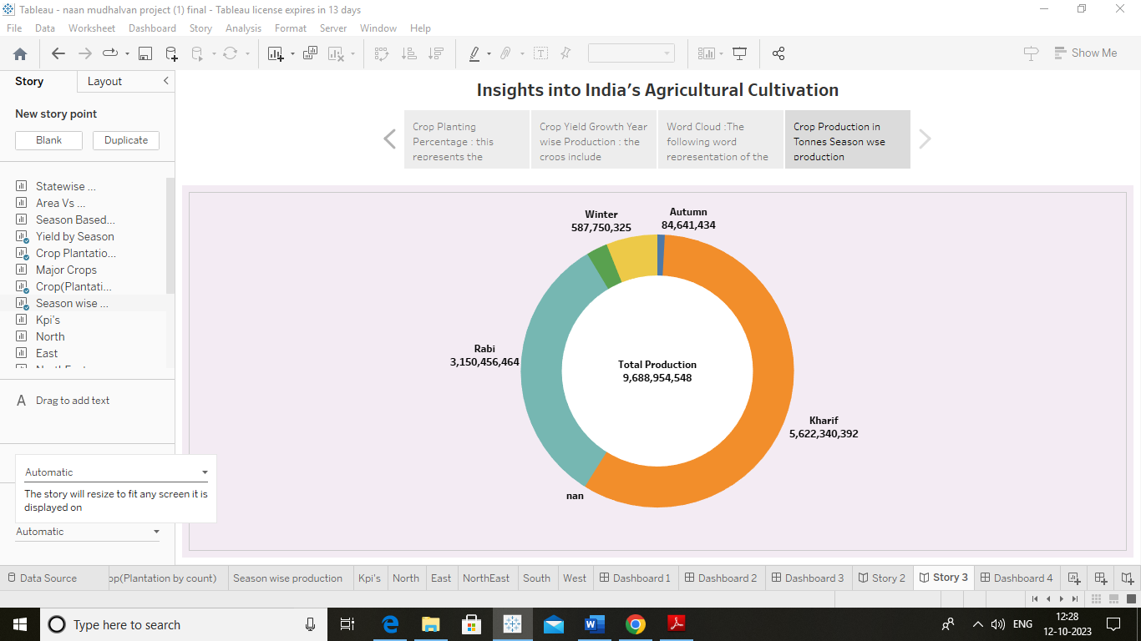

**4.Advantages**:

1.lnformed businesses make smarter choices in agriculture.

2.Better Farming: Encourages improved farming

techniques, potentially boosting crop yields.

3.Food Security: Contributes to ensuring a stable food

supply tor India's population .

4.Environmental Care: Promotes sustainable farming

practices that protect the environment.

5.Economic Growth: Benefits the Indian economy by

supporting the agriculture sector.

**Disadvantages:**

1.Data Challenges: Gathering accurate and current data

can be difficult.

2.Complexity: Agriculture involves many factors, and

simplifying them might miss important details.

3.Resource-lntensive: Requires time, effort, and

Resources ,including expert input.

4.Changing Factors: Crop production can vary due to

weather, markets, and policies, making long-term

predictions tricky.

5.lmplementation: Putting project recommendations into

action may require cooperation from multiple parties.

**5.Applications:**

1.Government Policies: Helps shape agricultural policies

for bet1er support to farmers and sustainable practices.

2.Smart Farming: Guides farmers in using technology for

efficient crop management.

3.Business Decisions: Aids businesses in making

informed investments and market strategies.

4.Climate Resilience: Identifies crops and practices suited

to changing weather.

5.Resource Efficiency: Helps allocate resources wisely for

reduced waste and a stable food supply.

6.Education: Used as a teaching tool in schools and

universities.

7.Research Foundation: Forms the basis for further

agricultural research.

8.Environmental Protection: Promotes sustainable

farming for conserving the environment.

9.Food Security: Contributes to strategies ensuring a

consistent food supply.

10.lnternational Collaboration: Encourages sharing

knowledge and solutions globally.

**6.Conclusion:**

On the whole, this project offers ideas and insights for better

farming in India. It helps policymakers, farmers, and

businesses make informed choices. By promoting

sustainable practices, it boosts food security, the economy,

and environmental protection. The project's data and

recommendations helps for smarter decisions, which benefits India and its people.

**7.Future Scope:**

1.Sustainable Farming: Promote and support sustainable

farming practices across India.

2.Enhanced Food Security: Contribute to strategies

ensuring a consistent and secure food supply for India's

population.

3.Economic Growth: Help the agriculture sector thrive,

benefiting the Indian economy and creating jobs.

4.Environmental Conservation: Encourage farming

methods that protect the environment and preserve natural

resources.

**THANKYOU**